

### VISVESVARAYA TECHNOLOGICAL UNIVERSITY

**BELAGAVI** -590018

**A Project Report On**

##### “TITLE OF PROJECT”

*DATABASE MANAGEMENT SYSTEM / BCS403*

***Bachelor of Engineering in Computer Science and Engineering***

Submitted by

#### STUDENT NAME (1OX23CSXXX)

Under the guidance of

#### Dr. R. Raghu

Associate Professor Department of CSE, TOCE

#### Department of Computer Science and Engineering The Oxford College of Engineering

Hosur Road, Bommanahalli, Bengaluru-560068

#### 2024-2025

**ACKNOWLEDGMENT**

Implementing a project is a monumental task that cannot be accomplished by one individual alone. Eventually, we are grateful to a number of individuals whose professional guidance, assistance and encouragement have made it a pleasant endeavour to undertake this work.

It gives us great pleasure in expressing our deep sense of gratitude to our respected Founder Chairman **Late. Sri S. Narasa Raju,** and to our respected Chairman **Dr. S.N.V.L Narasimha Raju,** for having provided us with great infrastructure and well-furnished labs.

We take this opportunity to express our profound gratitude to our respected Principal **Dr. H.N Ramesh** for his support.

We are grateful to the Head of the Department **Dr. KANAGAVALLI R,** for her unfailing encouragement and suggestion given to us in the course of our project work.

Timely guidance and clear deadlines are crucial for the successful completion of any task. We also extend our heartfelt thanks to Dr. R. Raghu, Associate Professor in the Department of CSE, for their constant support throughout the project

Finally, a note of thanks to the Department of Computer Science Engineering, both teaching and non- teaching staff for their co-operation extended to us.

We thank our parents for their constant support and encouragement. Last, but not the least, we would like to thank our peers and friends.

STUDENT NAME(1OX21CSXXX)

**ABSTRACT**

ONLINE EXAMINATION SYSTEM is a web-based examination system where examinations are given online. either through the internet or intranet using computer system. The main goal of this online examination system is to effectively evaluate the student thoroughly through a totally automated system that not only reduce the required time but also obtain fast and accurate results.

ONLINE EXAMINATION SYSTEM is an online test simulator is to take online examination, test in an efficient manner and no time wasting for manually checking of the test paper. The main objective of this web based online examination system is to efficiently evaluate the student thoroughly through a fully automated system that not only saves lot of time but also gives fast and accurate results. For students they give papers according to their convenience from any location by using internet and time and there is no need of using extra thing like paper, pen etc.

Functional Specification:

1. Registering new Student
2. Getting the student and staff info and storing it to databases
3. Getting the type and number of question paper
4. Generating result after the exam.

**CONTENTS**

#### Chapters Page No

**ACKNOWLEDGEMENT i**

**ABSTRACT ii**

1. **INTRODUCTION TO DBMS 1**
2. **SYSTEM SPECIFICATIONS 4**
3. **SYSTEM DESIGN 6**
4. **FUNCTIONS 9**
5. **MODULES OF ONLINE 11**

**EXAMINATION SYSTEM**

1. **CONCLUSION & FUTURE ENHANCEMENT 13**

**BIBILOGRAPHY 14**

**APPENDIX-A**

**SNAPSHOTS**

iii

**CHAPTER 1**

# INTRODUCTION

Database is a collection of data and Management System is a set of programs to store and retrieve those data. Based on this one can define DBMS as a collection of inter-related data and set of programs to store & access those data in an easy and effective manner.

###### What is the need of DBMS?

Database systems are basically developed for large amount of data. When dealing with huge amount of data, there are two things that require optimization: Storage of data and retrieval of data.

**Storage:** According to the principles of database systems, the data is stored in such a way that it acquires lot less space as the redundant data (duplicate data) has been removed before storage. Let’s take a layman example to understand this. In a banking system, suppose a customer is having two accounts, one is saving account and another is salary account. Let’s say bank stores saving account data at one place (these places are called tables we will learn them later) and salary account data at another place, in that case if the customer information such as customer name, address etc. are stored at both places then this is just a wastage of storage (redundancy/ duplication of data), to organize the data in a better way the information should be stored at one place and both the accounts should be linked to that information somehow. The same thing we achieve in DBMS.

**Fast Retrieval of data**: Along with storing the data in an optimized and systematic manner, it is also important that we retrieve the data quickly when needed. Database systems ensure that the data is retrieved as quickly as possible.

The choice of a database product is often influenced by factors such as:

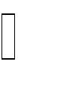 the computing platform (i.e., hardware, operating system)  the volume of data to be managed

 the number of transactions required per second

existing applications or interfaces that an organization may have

 support for heterogeneous and/or distributed computing  cost

vendor support

###### Design and Modeling:

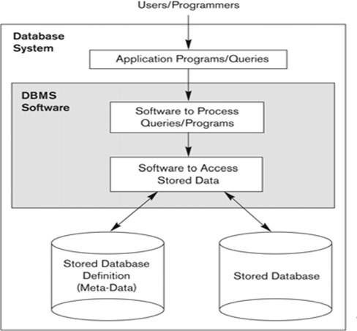The first task of a database designer is to produce a conceptual datamodel that reflects the structure of the information to be held in the database. A common approach to this is to develop an entity-relationship model, often with the aid of drawing tools. Another popular approach is the Unified Modeling Language. A successful data model will accurately reflect the possible state of the external world being modeled: for example, if people can have more than one phone number, it will allow this information to be captured.

**Figure 1.1: Simplified database system environment**

###### Objective

The main objective of this project is to determine how an interactive inventory management system helps in the smooth functioning of a warehouse compared to traditional inventory management, by digitizing all the records and transacting everything on a computer rather than on paper. This project is a two-tier architecture application.

###### Problem Statement

Existing systems for Warehouse Inventory Management are very inefficient and mostly involve a lot of manual work to be done by the manager of the system. With this project, we want to automate as many tasks as possible using the available technology and the internet.

###### Scope of the report

The essential framework of this report would be to elaborate the design of E.R-diagram, Schema Diagram and to display how the modules of the program work in order to achieve the automation.

**CHAPTER 2**

## SYSTEM AND SOFTWARE REQUIREMENTS AND SPECIFICATIONS

The program works on Desktop PC and is executed using a PHP 5 interface which interacts with a MySQL database running on localhost.

* 1. **FUNCTIONAL REQUIREMENTS**

A description of the facility or feature required. Functional requirements deal with what the system should do or provide for users. They include description of the required functions, outlines of associated reports or online queries, and details of data to be held in the system.

* + 1. **Interface Requirements:**

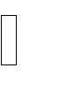 The system shall provide an option to add/delete quizzes with questions.  The system shall provide an option to see and attend the quizzes.

 The system should give option for login for staffs and students.  The system shall provide option to see scores.

* 1. **NON-FUNCTIONAL REQUIREMENTS:**

Non-functional requirements define the overall qualities or attributes of the resulting system.

* + 1. **Usability**

Usability is the ease with which a user can learn to operate the online examination system and get results.

* + 1. **Security**

Security requirements are included in a system to ensure:  All questions and users are well secured

SQL injection is prevented

Online Examination System System Specification

* + 1. **Reliability**

Reliability is the ability of a system to perform its required functions under stated conditions for a specific period of time. Constraints on the run-time behavior of the system can be considered under two separate headings:

 Availability: is the system available for service when requested by end-users.

 Failure rate: how often does the system fail to deliver the service as expected by end- users.

* 1. **SOFTWARE REQUIREMENTS**

Programming language : PHP, MYSQL

Operating system : ANY OS (Recommended**:** Windows8,

Windows Vista, Windows XP) Application required : Standalone desktop application & Xampp Coding language : PHP,HTML,CSS,Javascript

* 1. **HARDWARE REQUIREMENTS**

CPU : Pentium IV 2.4 GHz or above Memory (Primary) : 512 MB, 1 GB or above

Hard Disk : 40 GB, 80GB, 160GB or above

Monitor : 15 VGA color

**CHAPTER: 3**

## ER DIAGRAM, SCHEMA DIAGRAM

This chapter of the report describes the structure of the project, followed by Entity Relationship Diagram, Schema Diagram and the table structures.

**3.1 ER Diagram with relationships and cardinality ratio**

An entity relationship model*,* also called an entity-relationship (ER) diagram*,* is a graphical representation of entities and their relationships to each other, typically used in computing in regard to the organization of data within databases or information systems. An entity is a piece of data-an object or concept about which data is stored.

The cardinalit*y* or fundamental principle of one data aspect with respect to another is a critical feature. The relationship of one to the other must be precise and exact between each other in order to explain how each aspect links together. In simple words Cardinality is a way to define the relationship between two entities.

The following are the notations of the ER diagram:

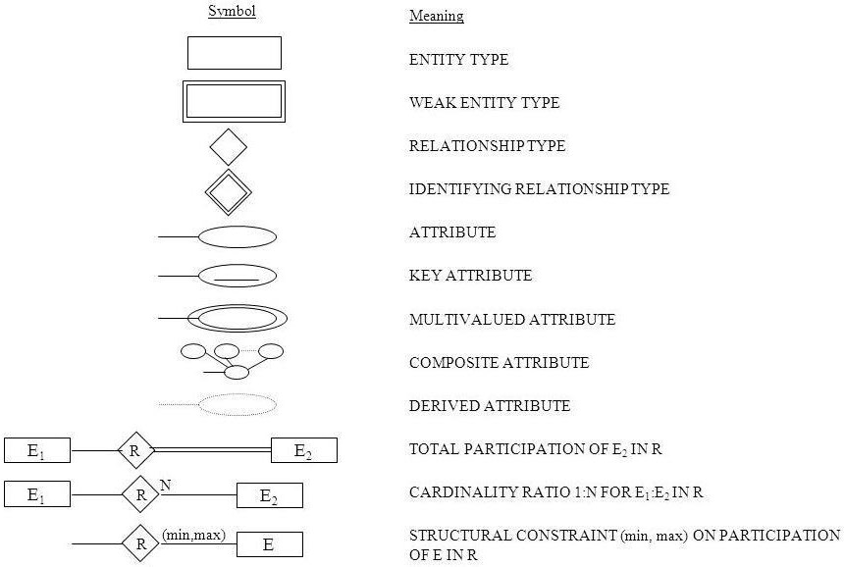

**Fig 3.1: Notations for ER Diagrams**

The ER diagram below shows the relationship between the many tables that exist in the database for the functioning of Warehouse Inventory Management System.

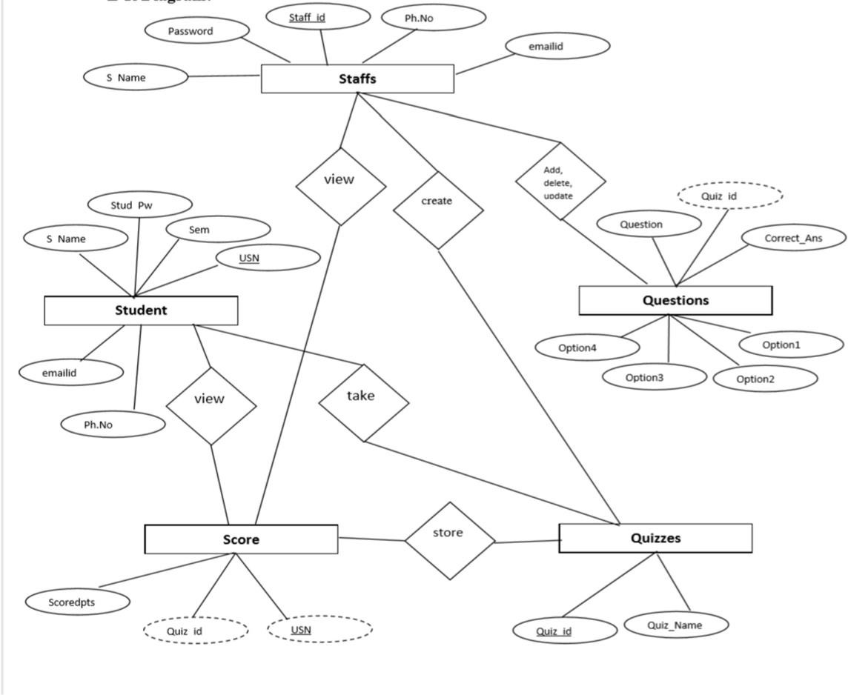

**Fig 3.2: ER Diagram of Online Examination System**

**3.3 Schema Diagram**

In any data model it is important to distinguish between the description of the database and the database itself. The description of a database is called the database schema, which is specified during database design and is not expected to change frequently.

A displayed schema is called a schema diagram. A schema diagram displays only some aspects of a schema, such as the names of record types and data items, and some types of constraints.

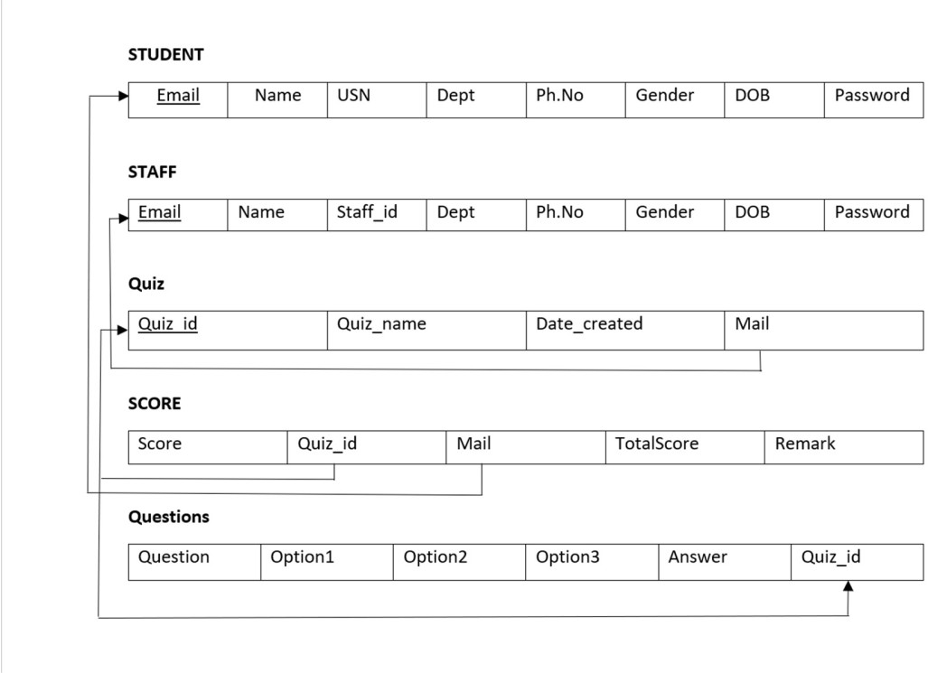

**Fig 3.3: Schema Diagram**

**CHAPTER: 4**

# IMPLEMENTATIONS

This chapter of the report describes the Functions, packages and modules used in the project:

###### Libraries and Frameworks PHP

PHP is Hypertext Pre-processor is a general-purpose programming language originally designed for web development.

##### HTML

Hypertext Markup Language is the standard markup language for documents designed to be displayed in a web browser. It can be assisted by technologies such as Cascading Style Sheets and scripting languages such as JavaScript.

##### CSS

Cascading Style Sheets is a style sheet language used for describing the presentation of a document written in a markup language like HTML. CSS is a cornerstone technology of the World Wide Web, alongside HTML and JavaScript. Functional Modules

###### JavaScript

JavaScript, often abbreviated as JS, is a high-level, interpreted scripting language that conforms to the ECMAScript specification. JavaScript has curly-bracket syntax, dynamic typing, prototype-based object-orientation, and first-class functions.

###### PHP Mailer

PHPMailer is a code library to send emails safely and easily via PHP code from a web server. Sending emails directly by PHP code requires a high-level familiarity to SMTP standard protocol and related issues and vulnerabilities about Email injection for spamming. So, we used PHP Mailer

nline Examination System Functions

###### Functional Modules

The functional modules included in the project are listed below:

###### Insert Module:

This module provides the functionality of collecting the required data from the designed interface and transmitting it to the appropriate table present in the database designed for this project. If the provided data does not satisfy the given constraints, it must refrain from storing it into the database.

###### Update Module:

This module again has the functionality of collecting the data from the designed interface, but it updates the already existing tuple that matches the provided primary key of the tuple to be updated, by replacing the existing attribute values with the newly collected data. Again, if the

newly provided data does not satisfy the given constraints, it must refrain from updating the corresponding tuple.

###### Delete Module:

The delete counterpart is loaded with the ability to delete a single or multiple records from the table. It searches for the tuple, in the query specified table, based on the provided value for an attribute. Admin can delete in the interface, based on which delete module searches for the record corresponding to that provided attribute value and deletes the record.

###### Retrieve Module:

The retrieve module has a basic functionality of accessing the entire specified table from the database and displays it.

###### Trigger Module:

Trigger in database is set of statements that are executed after an event occurs on the specified table. This is useful for logs wherein every change in database can be logged which helps keep a track of all changes/transactions on the database.

## MODULES IN ONLINE EXAMINATION SYSTEM

Online Examination System is that which enables the Students & Teachers to register for the system. Students are allowed to take the online test and see their progress. Also, it enables the Teachers to add, delete, update the test questions and also to keep track of the student progress.

 **Student ** **Staff**

 **Login**

 **Add/Remove quizzes and questions Score**

**Student:**

Student has to log in to the system and can then view all the quizzes. Student can see the quiz list and attend the quizzes. After attending the quizzes students will get instant result and the same will be stored in the database.

**Staff:**

Staff also has to log in to the system first, then they can add/remove quizzes. They

can see the progress and they can also update the existing quiz.

**Login:**

Login is must and should for both staff and student. So that all records will be safely saved to the database. If someone had forgot the password ,one can reset that password.

**Add/Remove quiz and question:**

Staff can add, remove the quiz. And also they can add extra questions to an existing

quiz.

**Score:**

Staff can see the scoreboard of the quiz which is added by him/her. And student

can see the score of the quiz which he/she is attended.

# CONCLUSION

The online examination system provides better functionality for an examination to be more efficient and reduce manual paperwork in order to automate all possible tasks. For implementing this system, PHP, HTML, CSS, JavaScript and MySql are used.

The system comprises of following features:

 Management of quiz.  Automated grading.

Adding/deleting quizzes and questions.

##### SCOPE OF ENHANCEMENT

There are also few features which can be integrated with the system to make it more flexible.

Below list shows the future points to be considered:

 Implementing the timer for the quiz.

 Sending mails on sign up and when student takes the quiz.  Supporting all type of questions including MCQ’s.

Including Programming Questiond where user can compile or interpret on site only.

# BIBLIOGRAPHY

##### BOOK REFERENCE

1. Database System Models, Languages, Ramez Elmasri and Sham Kant B. Navathe, 7th Edition, 2017 Pearson.
2. Fundamentals of Web Development, Randy Connolly and Ricardo Hoar ,First Impression, 2016 Pearson

##### WEBSITES

1. [www.stackoverflow.com](http://www.stackoverflow.com/)
2. [www.youtube.com](http://www.youtube.com/)
3. https:/[/www.php.net](http://www.php.net/)
4. [www.google.com](http://www.google.com/)
5. https:/[/www.w3schools.com](http://www.w3schools.com/)

**APPENDIX A**

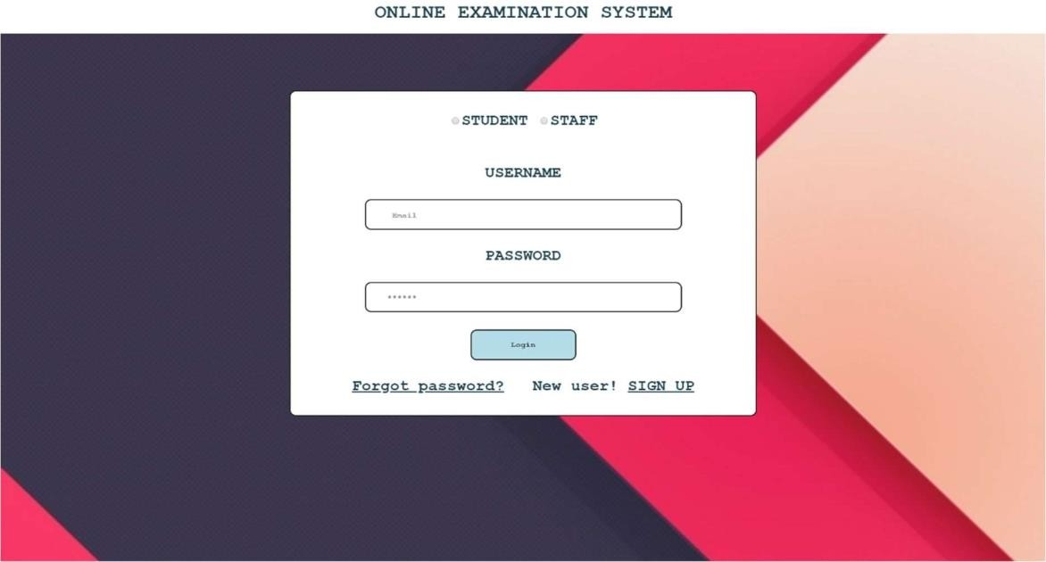**SNAPSHOTS**

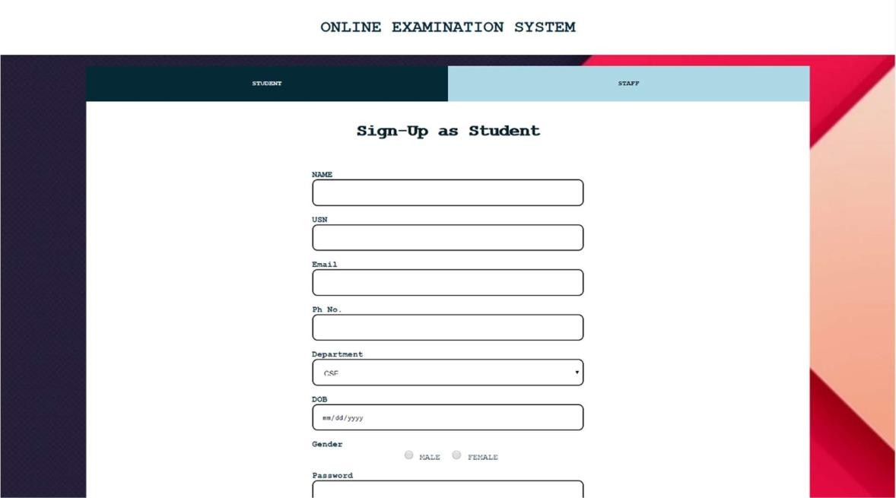**Snapshot 1: Start page of the project**

**Snapshot 2: Sign Up Page**

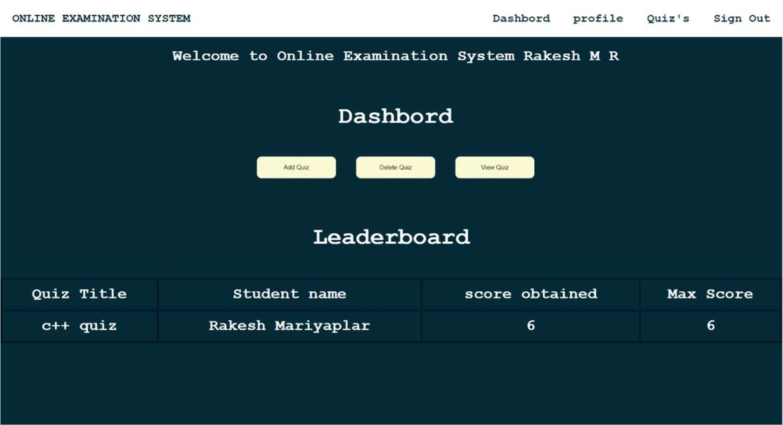

**Snapshot 2: Dashboard for Staff**

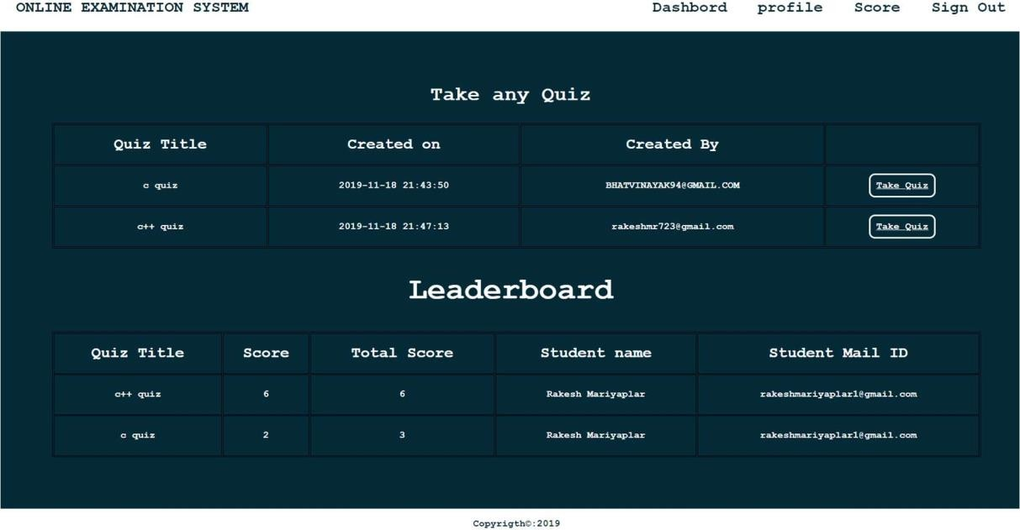

**Snapshot 3: Dashboard for Students**

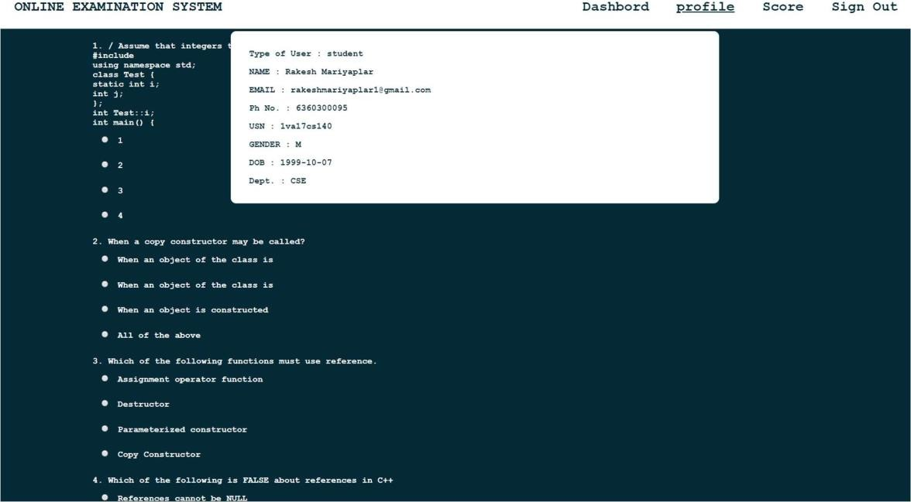

**Snapshot 4: Profile view of Student**

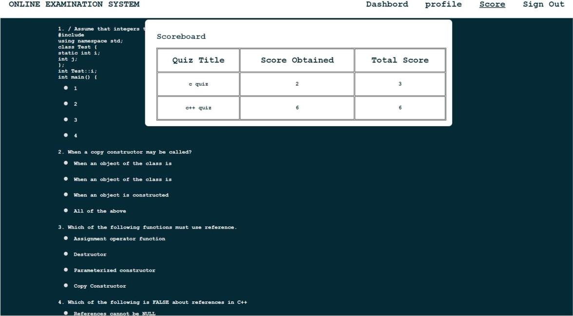

**Snapshot 5: Scoreboard of user**

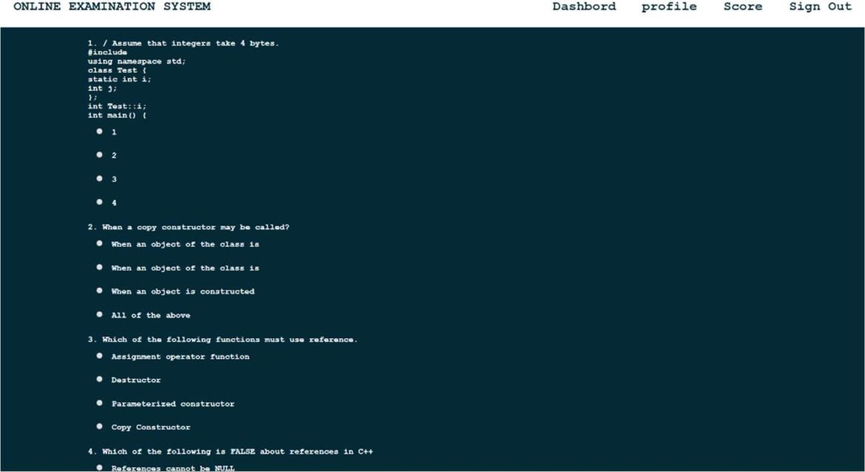

**Snapshot 6: Taking Quiz by Student**

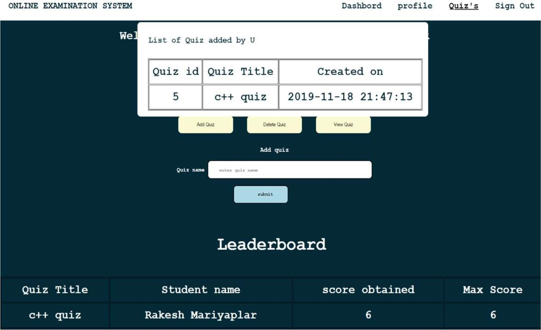

**Snapshot 7: Quiz Added by The Staff**

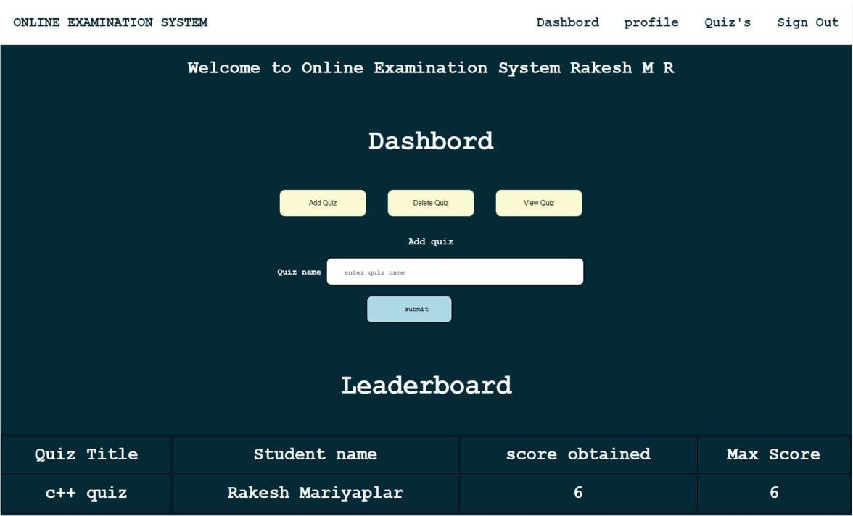

**Snapshot 8: Adding quiz page by staff**

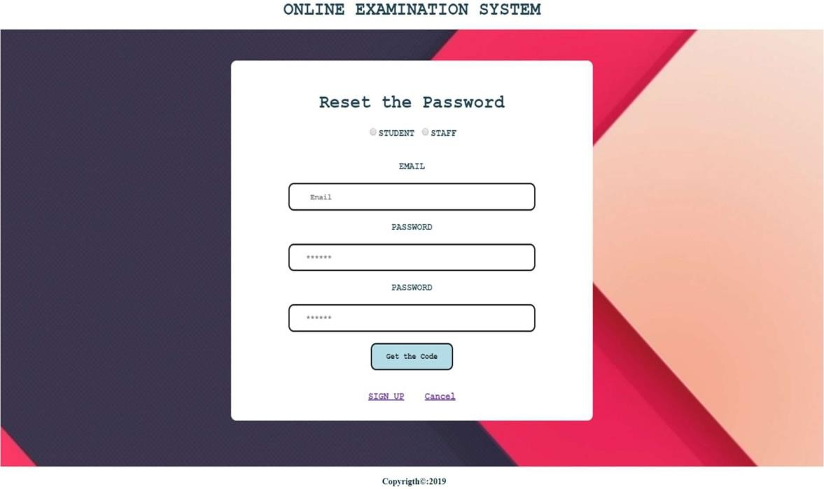

**Snapshot 9: Request for security code**

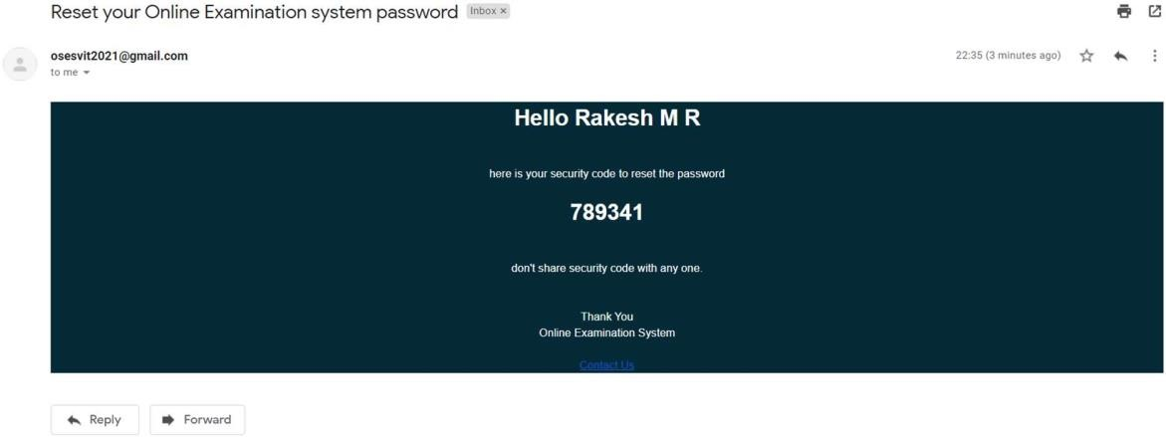

**Snapshot 10: mail received by user with security code**

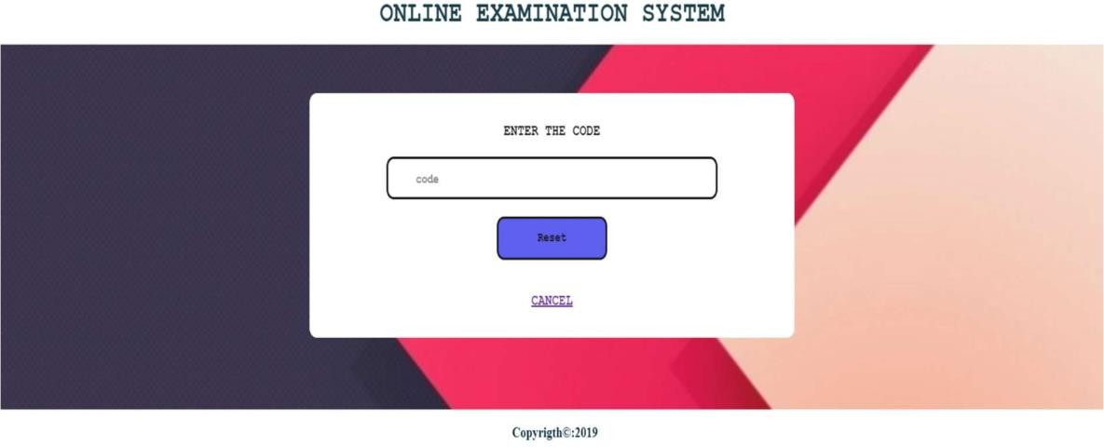

**Snapshot 11: verifying the security code and update password**